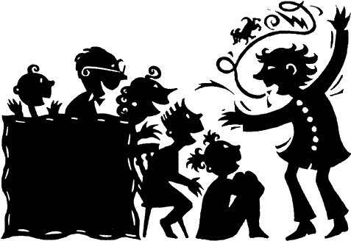The Art of the Personal Story
Crafting your own story to engage your audience.

By Sharon Kirk Clifton, Writer and Raconteur
SKCwriter@aol.com

Keep in mind:
- You have an important story to tell.
- People want to hear your story. We are narrative beings.
- Your story reveals your values and connects your values to the shared values of your audience. Once your audience sees that, they have a reason to believe in you.
- When you share your story, you take a risk, making yourself vulnerable. Your courage inspires and enables others to tell their own stories.
- Not all stories have happy-ever-after endings. That’s okay. That’s honest.
- Personal stories can be cathartic for both you and your audience.
- Personal stories that engage the emotions—all the emotions— resonate with the audience. Remember, what truly engages an audience is not so much what the characters do, but what they think and feel, especially the main character, the one from whose perspective you’re telling. We writers call that deep point of view (DPOV).
- Even if you present your stories orally, be sure to write them down. They deserve to be preserved, and no one can do a better job of telling your stories than you! So DO TELL!
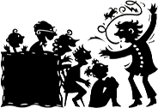
Mine the memories:
- Obviously, your own memories and experiences provide the rough diamonds for your stories. So do your family’s stories.
- Like a diamond freshly dug from the earth, gems from your life and family history require cutting and polishing.
- Some diamonds are for industrial use, while other are destined to become part of a jeweler’s creative artistry, to be set in a ring, a necklace, or a jewel-encrusted crown. So it is with your stories.
- Determine your audience, and select from among your cache suitable ones.

Start digging:
Your family history, passed on through oral tradition, journals, diaries, letters, and articles, are the mother lode for stories. Look for the gems wherever they might be found, including dusty boxes in the home place attic, in the recollections of family members—especially those with strands of silver in their hair—and public places: library genealogy rooms, online sites, and historical society museums, for example. Dig deep. Seldom does one find diamonds strewn about on the ground.
Regarding your own stories, consider the following, for starters:
- What life lesson was your mom, dad, or a grandparent trying to teach you that you finally learned—the hard way?
- What holiday went all wrong, and how was it resolved?
- What was your first (or most memorable) job interview like, and what did you learn from that experience?
- Remember the time you were in charge of younger children and chaos ensued?
- What important life lesson did you learn that has carried you through some hard times as an adult?
- Tell about a special adventure you had as a young person.
- What activity did you enjoy as a child or teen that is still important in your life?
- What was the most difficult skill, art, craft, or thing in general you ever had to master?
- What is your most important or prominent personality trait, and how does it affect your life now?
- Remember that kid you couldn’t stand? Tell about that relationship and how it played out.
- Ever get hopelessly lost? How was that resolved?
- Remember that time when you were heroic? Tell about that.
- Come up with your own idea.
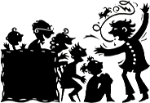

Cutting and polishing:
Storyteller Beth Horner lists seven questions you should ask yourself about your own story, whether it’s personal or family.
- What exactly is the story I want to tell?
- How do I transform facts, dates, and histories into living, breathing, characters?
- How do I connect my story to my listeners, making it universal?
This is the most important question to ask and answer, if you’re putting your story out there to an audience. Think about your story. Think about the things that most of us experience in life. For example major emotions, physical needs, love, hate, gain, loss, faith, feelings of helplessness, dark nights of the soul, friendship, grief, satisfaction, peace, passion, important “firsts,” etc. What in your story plugs in to such a commonality? Play to that.
- How do I fill in holes in the available research [or my own memories]?
If it’s a historical family story, learn what you can or can presume from what you know the character, the times, and the customs or culture. Utilize just enough creative license to bring the story alive. Do the same thing for a personal story, but you have the advantage here of personally knowing the main character—YOU!—and others involved, so improvise based on what you know would be characteristic.
- What is the best structure for this story?
Many possibilities here, including straight narrative; begin with a later scene, flash back, work up to beginning scene and beyond to conclusion; begin at the end and work backward. Experiment as you prepare the story. What works best?
- What do I leave in? What do I take out?
Once you determine your common ground between the story and the audience and once you settle on the structure, this question will solve itself. Retain only those things that clearly pertain to the commonality and the structure; chip away the rest. (Lest we forget, we’re cutting a beautiful diamond. )
- What is this story really about?
What keeps niggling around in the back 40 of your mind? What idea invades this whole process, as you craft your story? What’s begging to be addressed? Examine that thing. It may very well be what your story is really about. Or, at least, it may hold the key.

Tidying Up:
- Every story, whether written or told, exhibits the three elements you learned in third grade: a beginning, a middle, and an ending.
- Hook ‘em! Snag ‘em! Grab ‘em by the throat and don’t let go! That’s how you begin. Spend some time here. Come up with a killer first sentence and run from there. It doesn’t have to be loud and boisterous. It can be quiet and enigmatic or downright funny. But it should captivate the audience’s attention.
- Climb the mountain slowly toward the summit, the high point, the heart, the climax of your story. You want the diamond to sparkle in the light of your telling. Salient sensory details do that. As the events of your account unfold, what smells were in the air? What did you hear, both within the confines of your space and beyond? What did you feel? What were your emotions? Keep a light hand when using visual description; use the essentials only, to plunk the audience into your scene. Did you taste something? Did gorge rise up in your throat out of fear?
- Talk the talk. Dialogue is important in a story. People like to hear what others say and how they say it. If you’re telling orally, use your telling tools: vocal dynamics, gestures, facial expression, eye contact, body language, and character idiosyncrasies.
Now you’re ready! Congratulations! Get your personal or family story out there.
Your audience awaits! DO TELL!

